**Data Design**

1. *Entity Relationship Diagram*

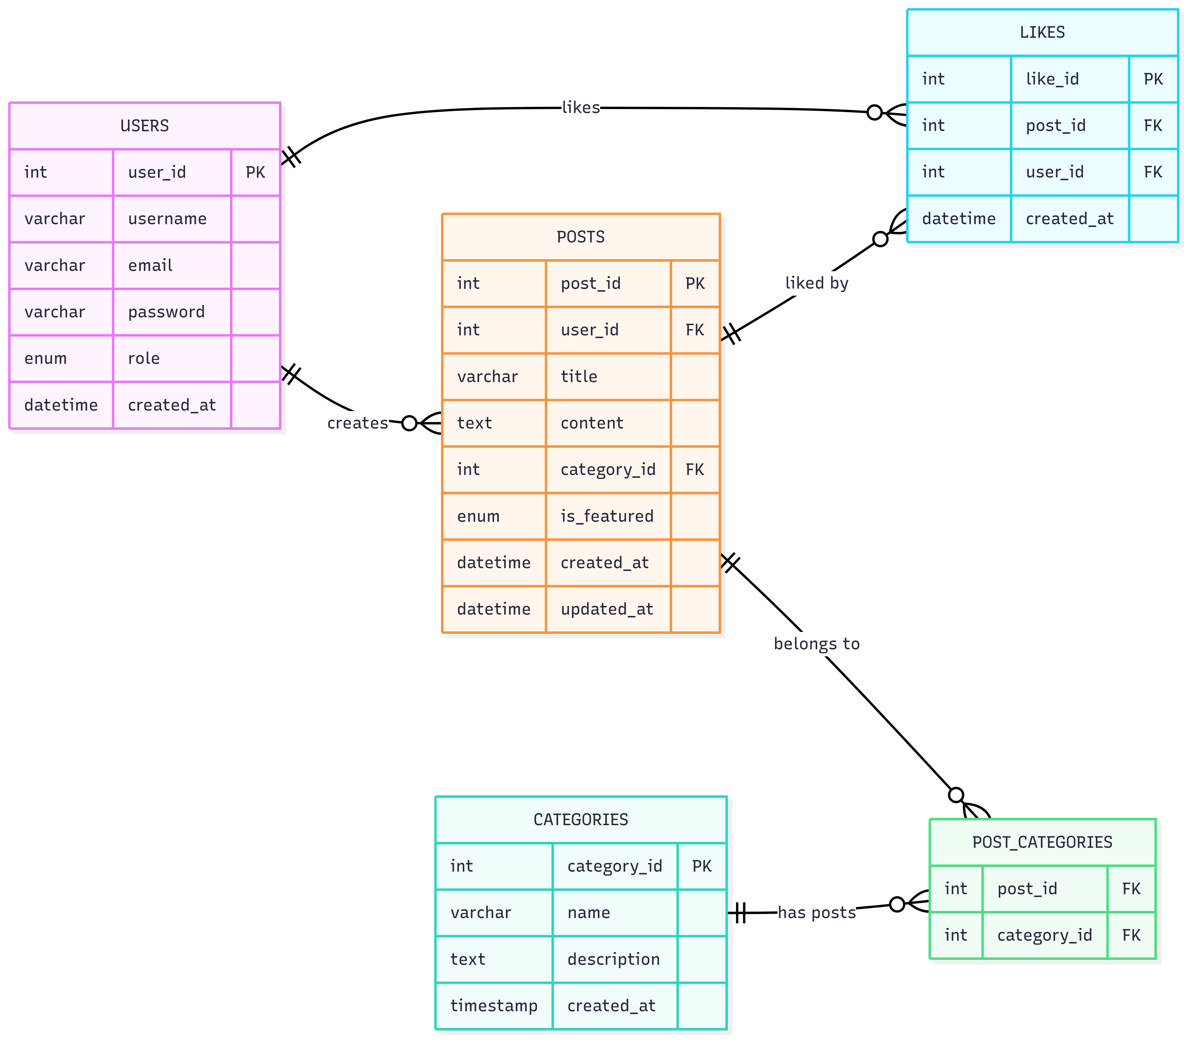

Figure 39: Data Design

1. ***Data Dictionary***

|  |  |  |
| --- | --- | --- |
| Attribute | Data Type | Description |
| user_id | int (PK) | Unique identifier for each user. |
| username | varchar | The display name of the user. |
| email | varchar | User's email address (used for login). |
| password | varchar | Hashed password for authentication. |
| role | enum | Role of the user ( 'admin', 'student'). |
| Created_at | datetime | Timestamp when the user was created. |

Table 1 – 1: Users

|  |  |  |
| --- | --- | --- |
| **Attribute** | **Data Type** | **Description** |
| post_id | int (PK) | Unique identifier for each post. |
| user_id | int (FK) | References user_id from the users table the author of the post. |
| title | varchar | Title of the post. |
| content | text | content of the post. |
| category_id | int (FK) | References category_id from the categories table |
| is_featured | enum | Indicates if the post is featured (approved, draft, pending or denied). |
| created_at | datetime | Timestamp when the post was created. |
| updated_at | datetime | Timestamp when the post was last updated. |

Table 1 – 2: Posts

|  |  |  |
| --- | --- | --- |
| **Attribute** | **Data Type** | **Description** |
| category_id | int (PK) | Unique identifier for each category. |
| name | varchar | Name of the category (Projects, Research, Art, Photography, Writing, Internship, Volunteering, Competitions, Reflections). |
| description | text | Description of the category. |
| created_at | timestamp | Timestamp when the category was created. |

Table 1 – 3: Categories

|  |  |  |
| --- | --- | --- |
| **Attribute** | **Data Type** | **Description** |
| post_id | int (FK) | References post_id from the posts table where the post being tagged. |
| category_id | int (FK) | References category_id from the categories table |

Table 1 – 3: Post Categories

|  |  |  |
| --- | --- | --- |
| **Attribute** | **Data Type** | **Description** |
| like_id | int (PK) | Unique identifier for each like. |
| post_id | int (FK) | References post_id in the post table where the post being liked. |
| user_id | int (FK) | References user_id in the users table where the user who liked the post. |
| created_at | datetime | Timestamp when the like was made. |

Table 1 – 4: Likes